|  |  |
| --- | --- |
| **PyPlanScoring, a tool for the evaluation of radiotherapy treatment plans.**  PyPlanScoring was developed to the [Radiation Knowledge initiative](https://radiationknowledge.org/) that carried out [radiotherapy plan competition in 2017](https://humanhealth.iaea.org/HHW/MedicalPhysics/Training_Events/Othertrainingevents/Radiotherapy_Plan_Competition/index.html). About 1847 planners joined from 97 countries. This software was the primary tool used for evaluating all the submitted plans.  The competition results were presented at ICARO2 conference.    Details at presentation slides [pages 46 – 51](https://humanhealth.iaea.org/HHW/RadiationOncology/ICARO2/Presentations/Session9C_01_Nobah.pdf)  and [video: 18:15 min](https://iaea.mediasite.com/Mediasite/Play/b5eb54fc73e94cb79c0a65eb8d5e54391d)  **Features:**   * Built using only open source python packages * High computation performance using [Numba compiler](http://numba.pydata.org/) targeting both CPU or NVIDIA/GPU without having to switch languages. * Full DICOM RT parsing - IMRT, VMAT or proton IMPT. * Structure contour extraction * 3D dose extraction and trilinear interpolation * Accurate DVH calculation   + Volume up-sampling     - Voxels up to 0.2 mm3     - Adaptive rasterisation     - High-resolution structures * Paddick’s Conformity index calculation at any complex or small structures with improved accuracy * **Validated**    + [benchmark DVH datasets](http://canislupusllc.com/portfolio-curvecompare/)   + Many shapes and dose gradients   + Hundreds of RT-Plans     Validation: Absolute DVH calculation    Figure 1 – DVH calculation using structures extracted from DICOM-RT files – Small or complex structures are up-sampled to 0.2mm3 voxel size |  |
| * PyPlanScoring can be a tool for patient data aggregation in research. * Big dataand outcomes analyses using data science tools. * Process all input data with a common DVH calculator that is proven superior * Robust solution to discriminate between treatment options by direct comparison of dose distributions |
|  |

## Operating Systems and Platforms

* Windows 7-10
* Debian based Linux

## System Requirements

Tested on desktop using:

* Memory: 8 GB minimum for high-resolution and multiprocessing
* Disk space: Approximately 1 GB plus adequate file space for database, log files, and python environment.
* Python 3.4 - 3.6 – Anaconda/Miniconda distribution.
* numpy >= 1.11.3
* numba >= 0.30.1
* pandas >= 0.19.2
* xlsxwriter >= 0.9.2
* scipy >= 0.18.1
* pydicom >= 0.9.9
* matplotlib >= 2.0.0
* joblib >= 0.10.3 – (multiprocessing package)
* [PySide](http://wiki.qt.io/PySide) for QUI

**Web app requirements.**

[Cherrypy](http://cherrypy.org/) (preferred) or [Flask](http://flask.pocoo.org/)

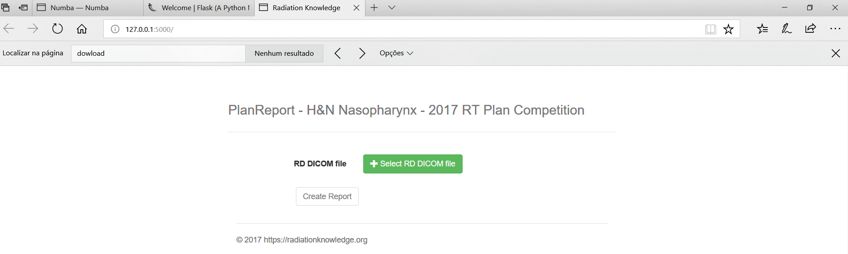

**PyPlanScoring diagram.**

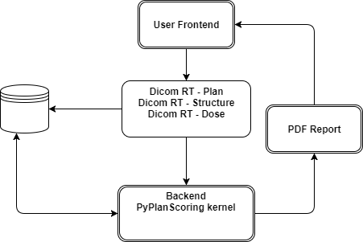

**Missing features:**

Dicom file database

Candidate: <https://pydicom.github.io/dicom-database/>

Live webapp besides a wordpress website.

Candidate: [https://docs.docker.com/compose/](https://docs.docker.com/compose/%20)

**Copyright (c) 2017 - Dr. Victor Gabriel Leandro Alves, D.Sc.**

**Medical Physicist – Radiation Oncology Physics**

**All rights reserved.**

**Contact Information**

Email: victorgabr@gmail.com

Linkedin:<https://www.linkedin.com/in/victor-gabriel-3369425/>

Lattes CV: <http://lattes.cnpq.br/0853212665883735>

Bitbucket (private): <https://bitbucket.org/victorgabr>

GitHub: <https://github.com/victorgabr>

**DISCLAIMER**

PyPlanScoring has no regulatory approval for clinical use. It is intended to calculate an approximate score during Radiation Knowledge’s RT Plan Competition or research. It is your responsibility to ensure compliance with applicable rules and regulations.

PyPlanScoring was built extending dicompyler’s DicomParser class to perform structure volume upsampling and dose trilinear interpolation, to improve the calculation accuracy on DVHs and conformity index radiotherapy from any complex or small structures. Dicompyler is released under a BSD license.

<https://github.com/bastula/dicompyler/blob/master/dicompyler/license.txt>